Assignment # 3  
JAVASCRIPT

**VARIABLES FOR NUMBERS**

1. Declare a variable called ***age*** & assign to it your age. Show  
   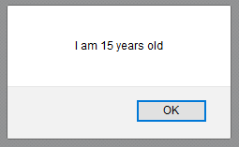your age in an alert box.
2. 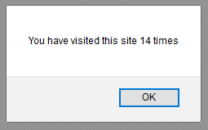Declare & initialize a variable to keep track of how many  
   times a visitor has visited a web page. Show his/her  
   number of visits on your web page. For example: “You  
   have visited this site N times”.
3. Declare a variable called ***birthYear*** & assign to it your  
   birth year. Show the following message in your browser:

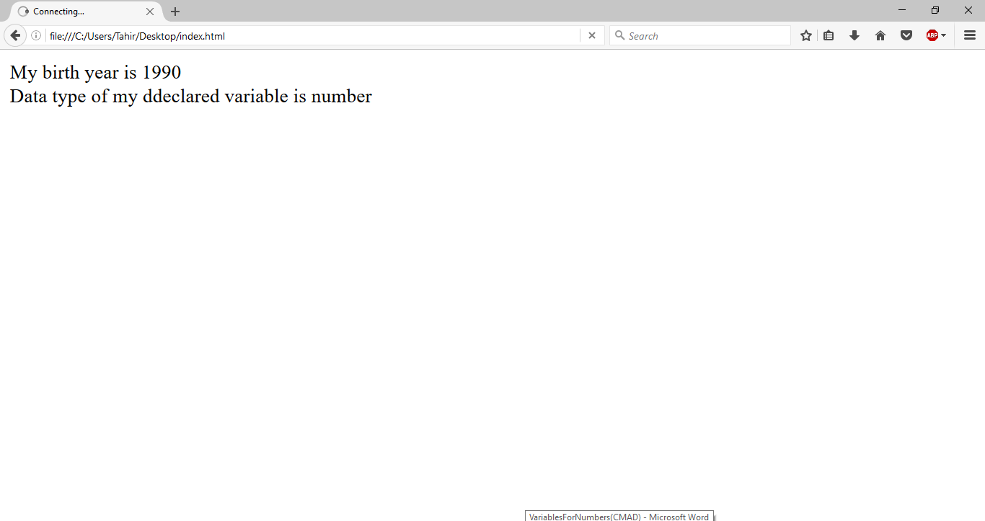

1. A visitor visits an online clothing store  
   www.xyzClothing.com . Write a script to store in variables  
   the following information:  
   a. Visitor’s name  
   b. Product title  
   c. Quantity i.e. how many products a visitor wants to  
   order  
   Show the following message in your browser: “**John  
   Doe** ordered **5 T-shirt**(s) on XYZ Clothing store”.

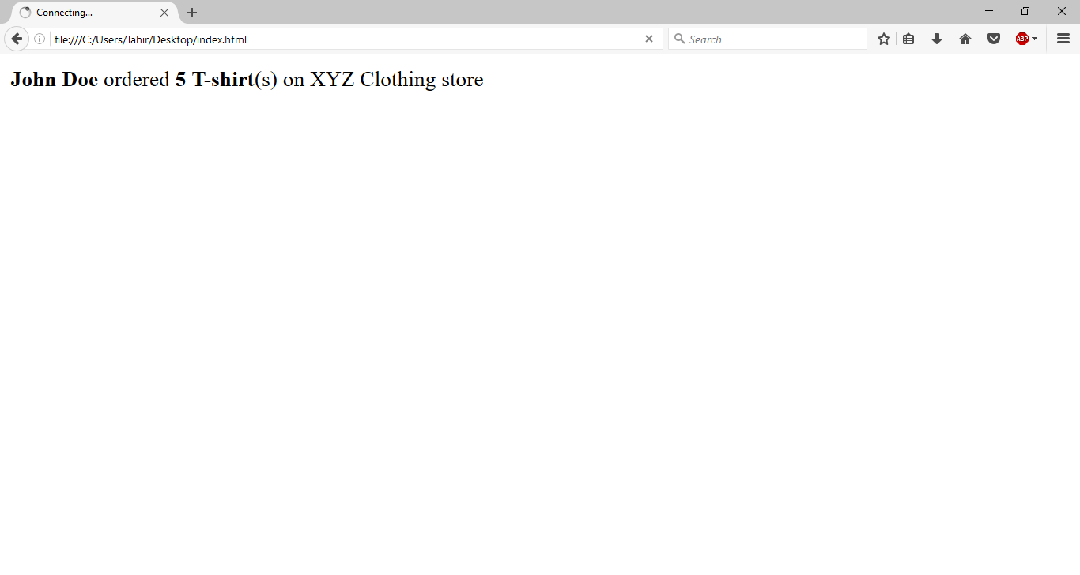

**-- END --**